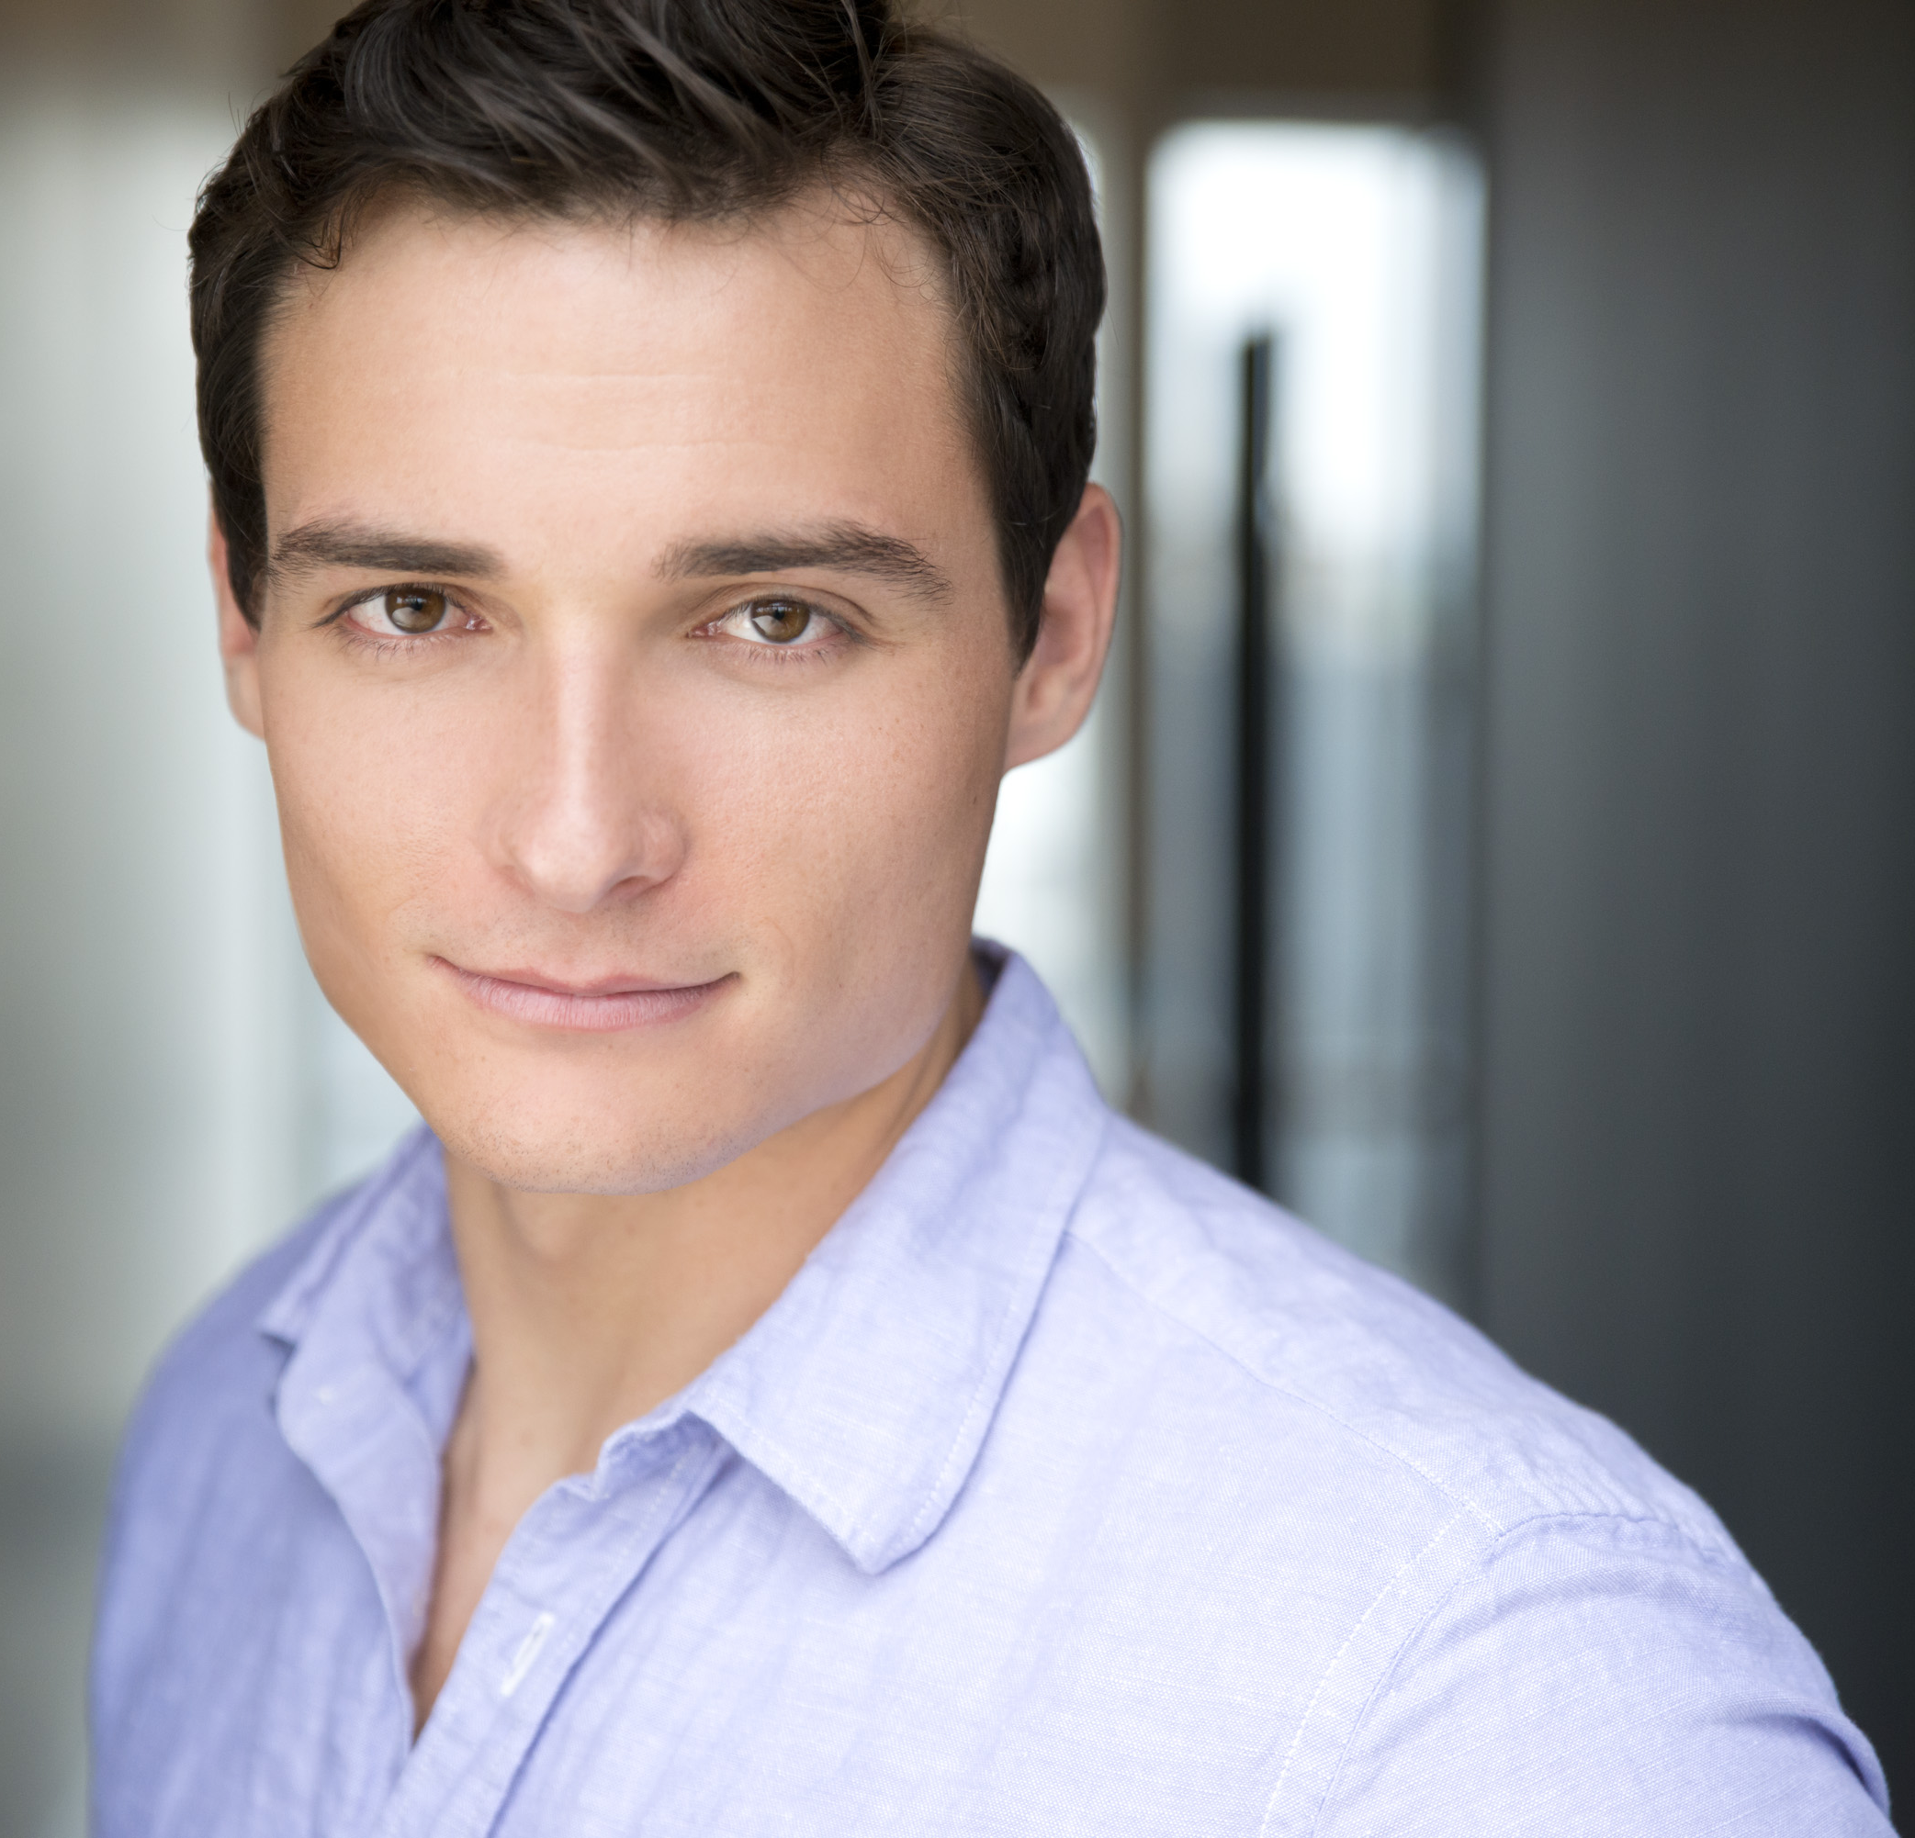
Thaddeus Pearson
www.thaddeuspearson.webstarts.com
6’4”, Brown Hair, Brown Eyes
Tenor (A3/G5)

WEST END
West Side Story (Joey McKneely) Tony Sundance/BB Productions

NATIONAL / INTERNATIONAL TOURS
West Side Story (Joey McKneely) Tony Sundance/BB Productions
Joseph…Dreamcoat (Andy Blankenbuehler) Joseph Cover Troika Entertainment
West Side Story (David Saint) Tony Cover/Federico Troika Entertainment

REGIONAL THEATRE
Grease Danny Zuko Gretna Theatre
Meet Me in St. Louis John Truitt Gretna Theatre
Sally and Tom Thomas Jefferson Castillo Theatre
Smokey Joes Café Victor William Clare Ent.

COLLEGIATE THEATRE
Damn Yankees Joe Hardy University of Florida
Hair Claude University of Florida
City of Angels Stone University of Florida
Floyd Collins Homer University of Florida
The Rocky Horror Show Brad Majors University of Florida
Susannah Sam Polk University of Florida
Pippin Louis University of Florida
Barefoot in the Park Paul Florida School of the Arts
Lucky Stiff Vinnie di Ruzzio Florida School of the Arts
Big River Dick/Undertaker Florida School of the Arts

TRAINING
University of Florida: BFA Musical Theatre 2011 Graduate
Florida School of the Arts: AS Musical Theatre 2008 Graduate

SPECIAL SKILLS
Proficient in Tap/Jazz/Hip-Hop Dance, Drums/Percussion, Guitar, Sight Reading, A-Cappella Barbershop Harmony, Improv, Very Athletic, Excellent Racquet-baller, Valid Drivers License

